Project Report Template

1. Introduction

1.1Overview

Project Description

Administrator should be able to create all base data including Semester, Candidate, Course and

Lecturer, Lecturer should have the ability to create Internal Results, Dean, who is one of the Lecturer, should be the only one with ability to update Internal Results, Re-evaluation Can be initialized by Candidate for all Internal Results. Now only dean can update the marks after reevaluation.

1.2 Purpose:

The purpose of implementing a Customer Relationship Management (CRM) system for tracking the results of a candidate with internal marks is to streamline and automate the process of managing candidate data and performance. A CRM system can help educational institutions, such as universities or schools, to:

Centralize candidate data: A CRM system can help institutions to store candidate data in a centralized database, making it easy to access and manage. This can include information such as personal details, academic history, and internal marks.

Monitor candidate performance: A CRM system can help institutions to track candidate performance over time, including internal marks and other performance metrics. This can help educators to identify trends and patterns in candidate performance, and to take corrective action if needed.

Automate workflows: A CRM system can help institutions to automate workflows, such as sending out reminders to candidates to submit assignments or notifying educators of upcoming exams. This can help to reduce manual effort and improve efficiency

1. Problem Definition & Design Thinking
   1. Empathy Map

* 1. Ideation& Brainstorming Map

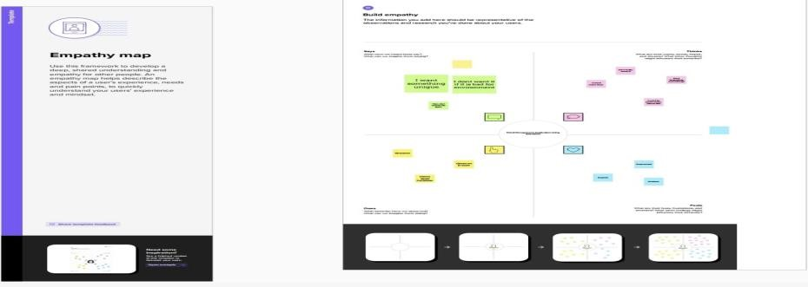

2. Result

3.1 Data model.

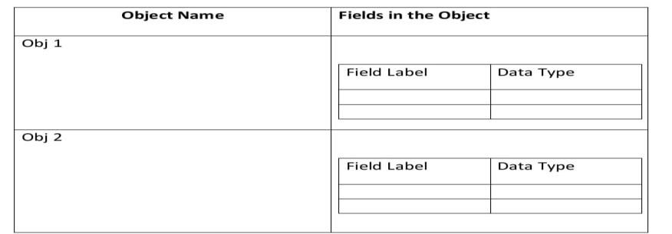

3.2Activity and Screenshots

Trailhead profile public URL

Team leader: <https://trailblazer.me/id/aezhil1>

Team member: https://trailblazer.me/id/stabi23

5.Advantages & Disadvantages

Advantage:

There are several advantages of implementing a Customer Relationship Management (CRM) system for tracking the results of a candidate with internal marks. Here are some of the key advantages:

Improved data management: By centralizing candidate data in a CRM system, educational institutions can improve their data management capabilities. This can make it easier to access, update, and maintain candidate information, reducing the risk of errors and inconsistencies.

Enhanced communication: A CRM system can provide educational institutions with tools for communicating more effectively with candidates. This can include automated messaging, personalized notifications based on candidate performance, and other features that help keep candidates engaged and informed.

Better decision-making: By tracking candidate performance over time, a CRM system can help educators to identify trends and patterns in performance, and to make data-driven decisions about how to improve academic outcomes.

Streamlined workflows: A CRM system can automate many of the administrative tasks associated with managing candidate data and performance, such as sending out reminders, notifications, and alerts. This can help to streamline workflows, reduce manual effort, and improve efficiency.

Improved collaboration: A CRM system can provide a platform for educators and administrators to collaborate more effectively, sharing information and insights about candidate performance and working together to improve academic outcomes.

Disadvantage:

There are some potential disadvantages of implementing a Customer Relationship Management (CRM) system for tracking the results of a candidate with internal marks. Here are some of the key disadvantages to consider:

Cost: Implementing a CRM system can be expensive, particularly if it requires significant customization or integration with other systems. Educational institutions may need to invest in hardware, software, and staff training to implement the system effectively.

Complexity: CRM systems can be complex and require a significant amount of time and effort to set up and configure. This can be particularly challenging for educational institutions with limited IT resources or staff.

Data security: Storing sensitive candidate data in a centralized database can raise security concerns. Educational institutions need to ensure that appropriate security measures are in place to protect candidate data from unauthorized access or theft.

Resistance to change: Some educators and staff may be resistant to adopting a new system, particularly if they are comfortable with existing processes and workflows. This can make it difficult to get buy-in and support for the implementation.

Technical issues: Like any software system, CRM systems can encounter technical issues or glitches that may impact performance or cause downtime. This can be particularly problematic during critical periods, such as exam season.

Application:

The application of implementing a Customer Relationship Management (CRM) system for tracking the results of a candidate with internal marks is relevant to a wide range of educational institutions, including schools, colleges, and universities. Here are some of the key applications of this type of system:

Student performance tracking: A CRM system can help educators to track student performance over time, including internal marks, grades, attendance, and other metrics. This can help educators to identify areas of strength and weakness, and to take corrective action if needed.

Personalized communication: A CRM system can help educators to communicate with students more effectively, sending out personalized messages based on their academic performance, interests, and needs. This can help to keep students engaged and informed, improving overall academic outcomes.

Workflow automation: A CRM system can automate many of the administrative tasks associated with managing student data and performance, such as sending out notifications, reminders, and alerts. This can help to streamline workflows and improve efficiency.

Conclusion:

In conclusion, implementing a Customer Relationship Management (CRM) system for tracking the results of a candidate with internal marks can provide a range of benefits to educational institutions. By centralizing candidate data, improving communication, and automating administrative tasks, a CRM system can help educators to improve their data management, collaboration, and decision-making capabilities. However, there are also potential drawbacks to consider, including cost, complexity, data security, resistance to change, and technical issues. To fully leverage the benefits of a CRM system and mitigate the risks, educational institutions need to carefully plan and implement the system, addressing concerns proactively and ensuring that all stakeholders are engaged and supportive. Ultimately, by leveraging the power of data and technology, educational institutions can help to improve academic outcomes and prepare candidates for success in their academic and professional careers.

Future scope:

The future scope of implementing a Customer Relationship Management (CRM) system for result tracking of a candidate with internal marks is significant. Here are some potential future developments in this area:

Predictive analytics: With the help of advanced analytics and machine learning techniques, a CRM system could be able to predict candidate performance more accurately. This could help educators to intervene early and provide targeted support to candidates who are at risk of falling behind.

Personalization: A CRM system could enable even greater personalization of communication with candidates, based on their academic performance, interests, and needs. This could help to further improve engagement and academic outcomes.

Integration with other systems: A CRM system could be integrated with other systems, such as learning management systems or assessment platforms, to provide a more holistic view of candidate performance. This could help educators to identify patterns and trends across multiple data sources, and to take more informed decisions.

Mobile access: A CRM system could be accessed via mobile devices, enabling educators and administrators to access candidate data and insights on the go. This could help to improve the flexibility and efficiency of workflows.

Blockchain technology: The use of blockchain technology could help to enhance the security and transparency of candidate data stored in a CRM system. This could be particularly relevant in cases where sensitive candidate data needs to be shared between different educational institutions or stakeholders.